Name : Arshiya Tabassum A

Superset ID : 6424209

**WEEK 7**

**Create a React Application named “cricketapp” with the following components:**

**Installation :**

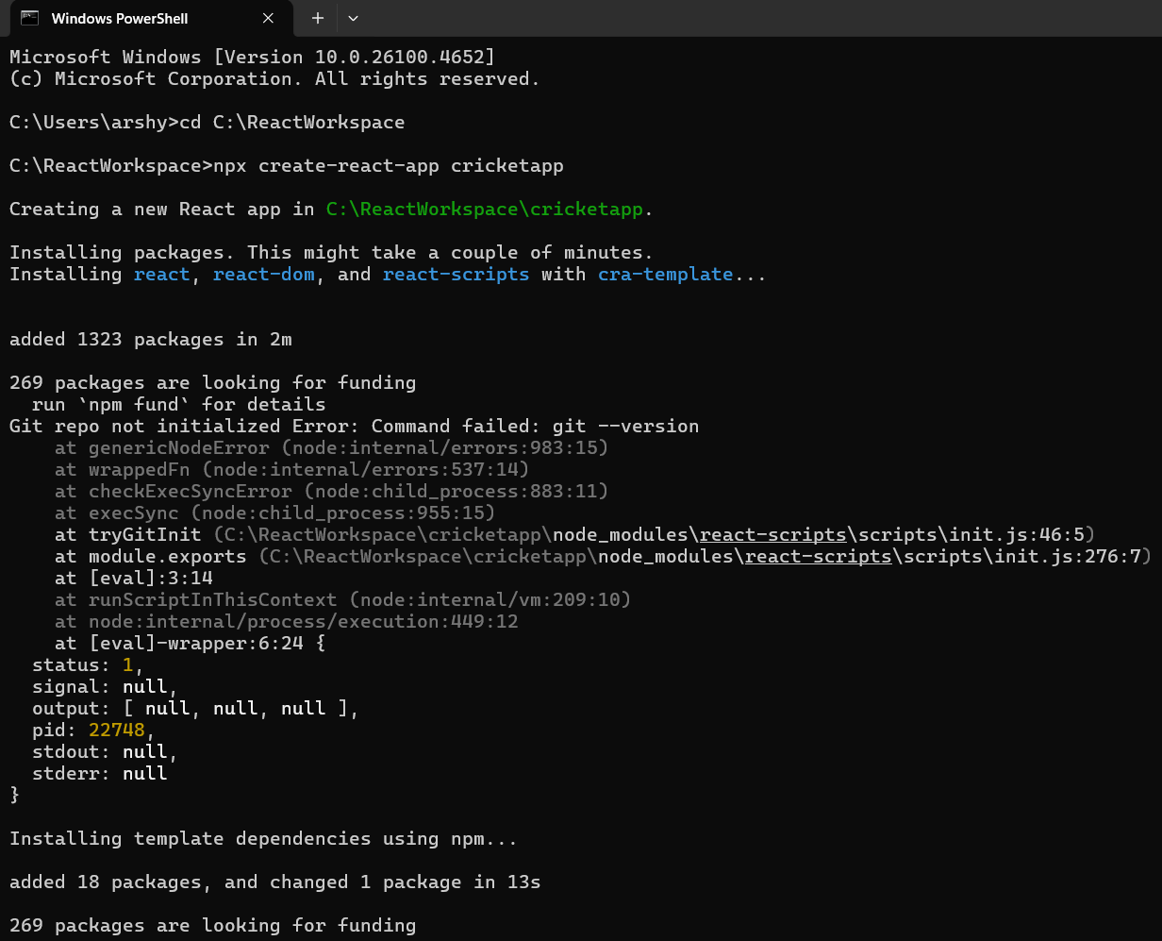

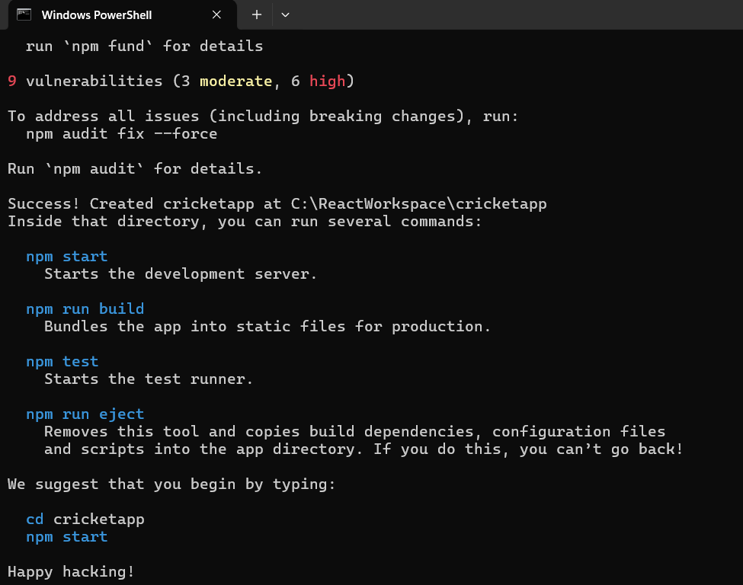

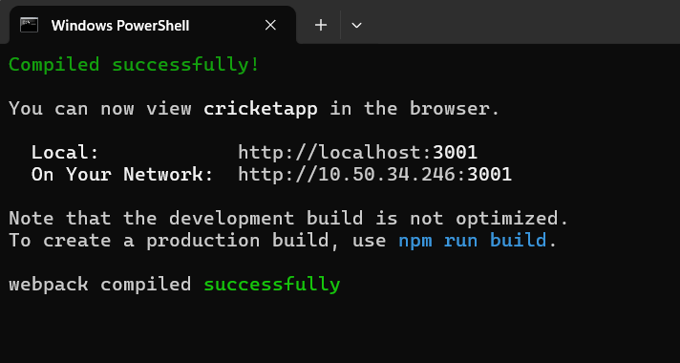

**App.js**

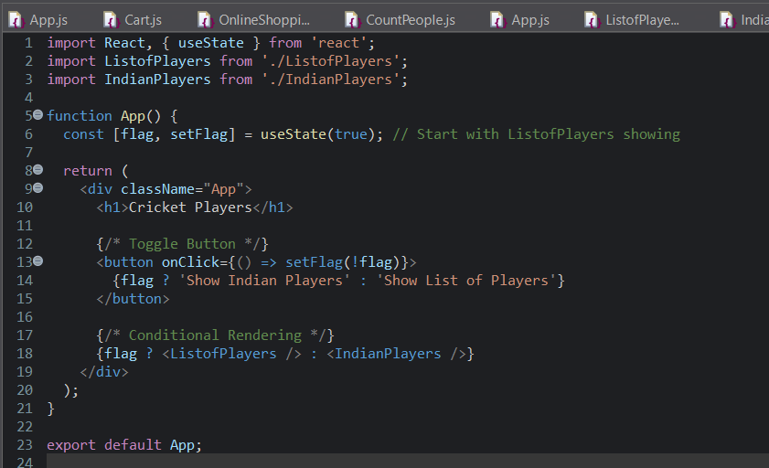

**IndianPlayers.js**

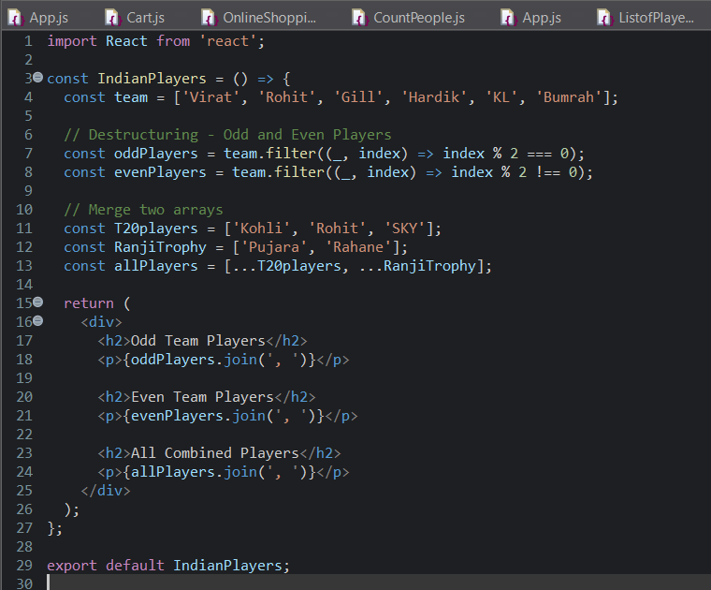

**ListOfPlayers.js**

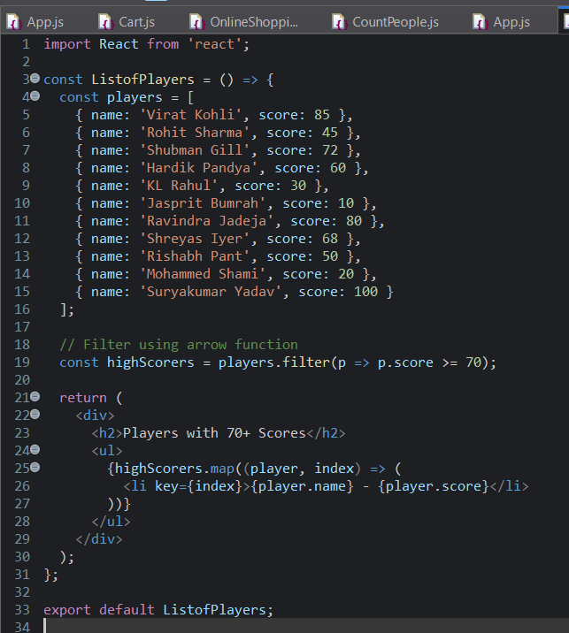

**Output :**

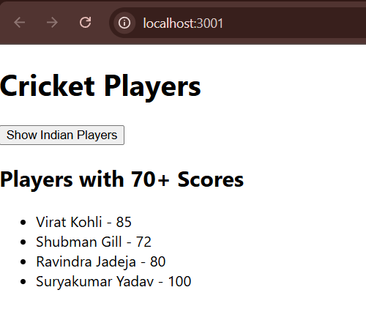

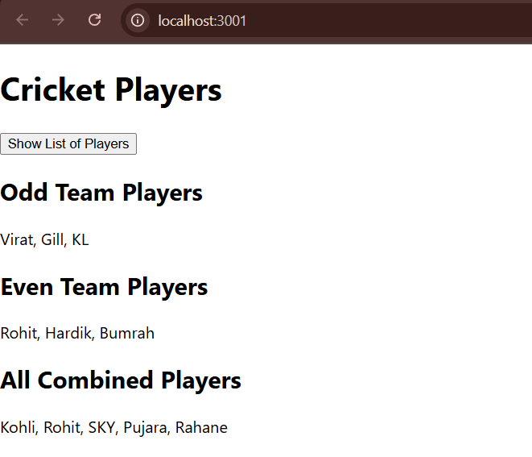

**Create an element to display the heading of the page.**

**Attribute to display the image of the office space**

**Create an object of office to display the details like Name, Rent and Address.**

**Create a list of Object and loop through the office space item to display more data.**

**To apply Css, Display the color of the Rent in Red if it’s below 60000 and in Green if it’s above 60000.**

**Installation :**

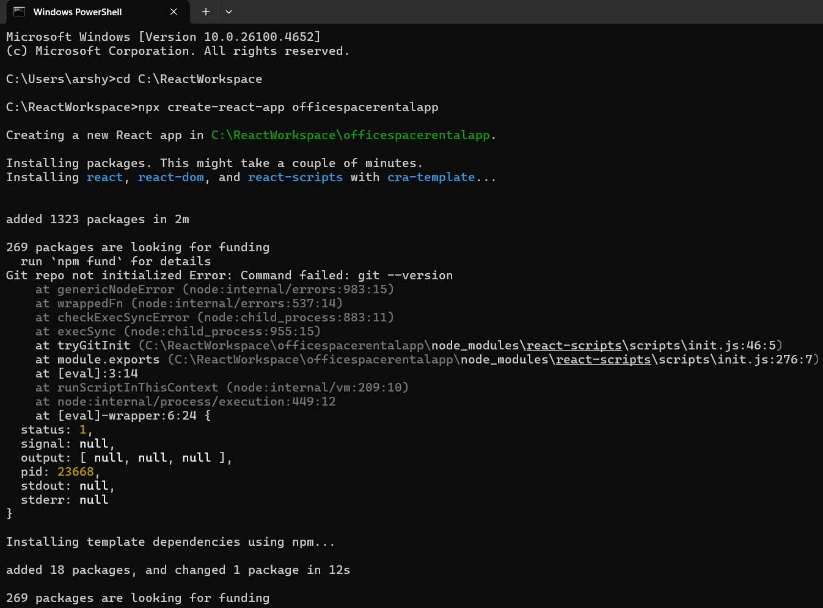

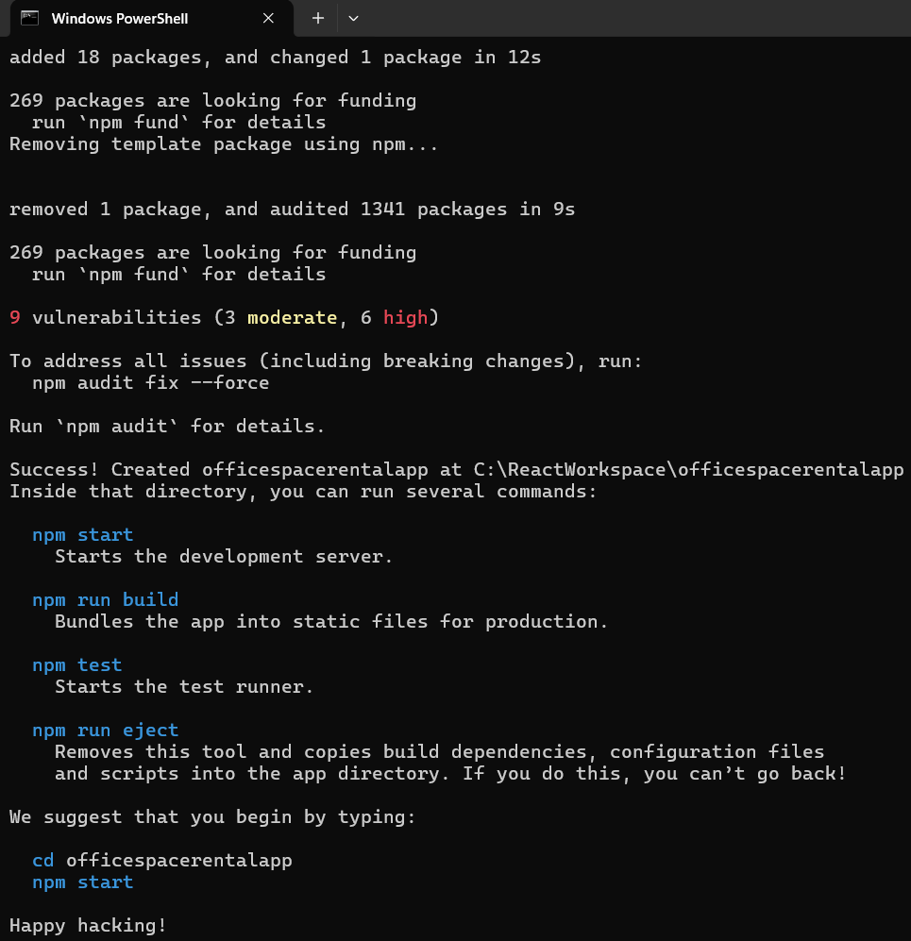

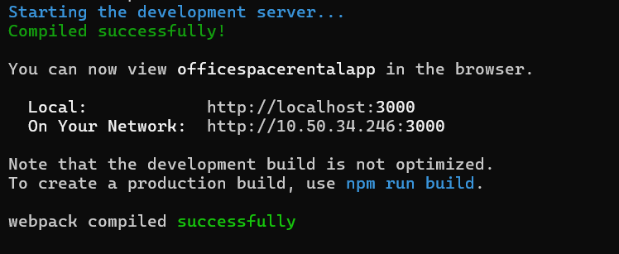

**App.js**

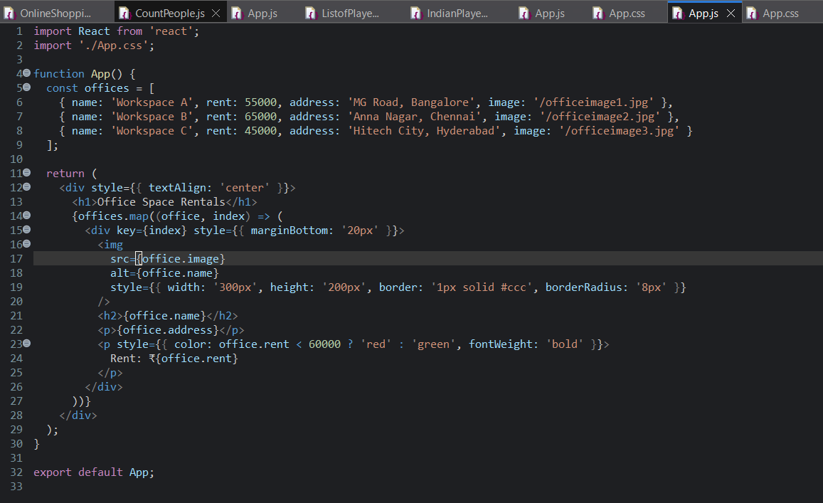

**App.css**

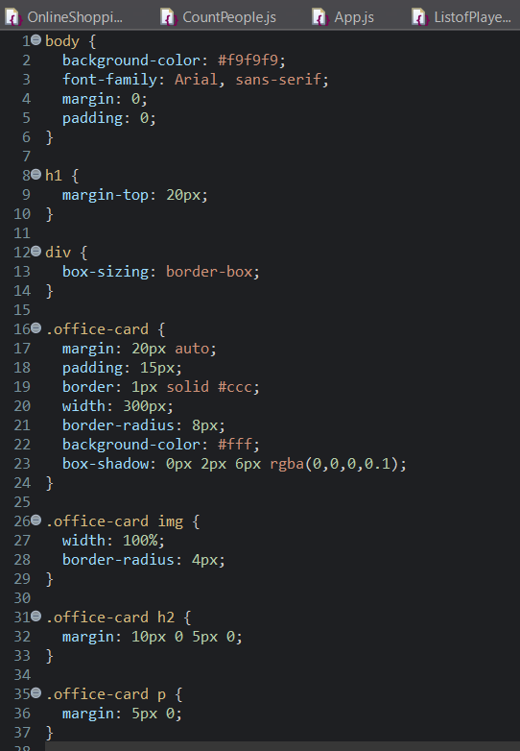

**Output**

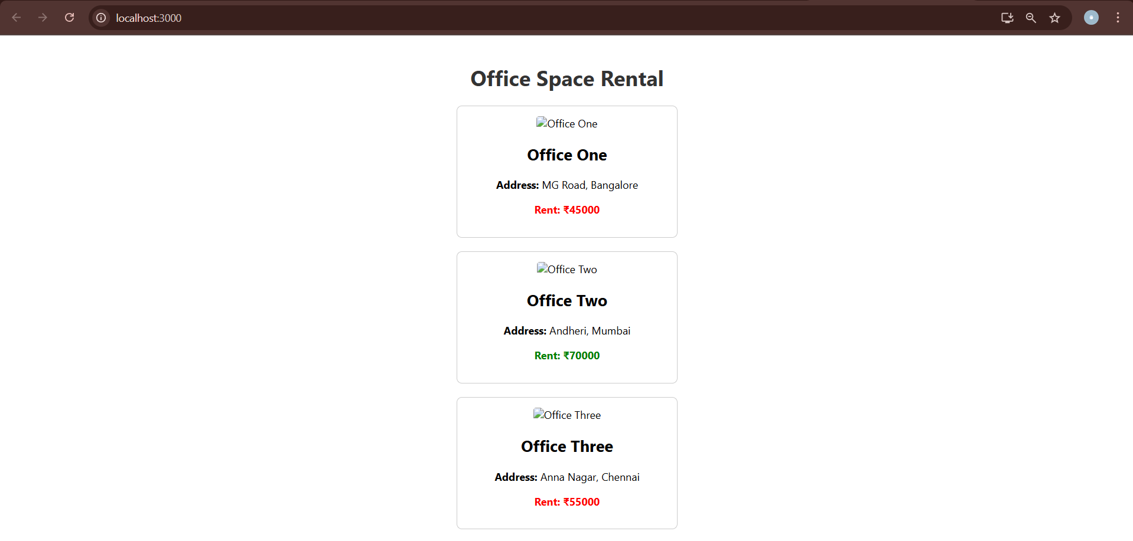

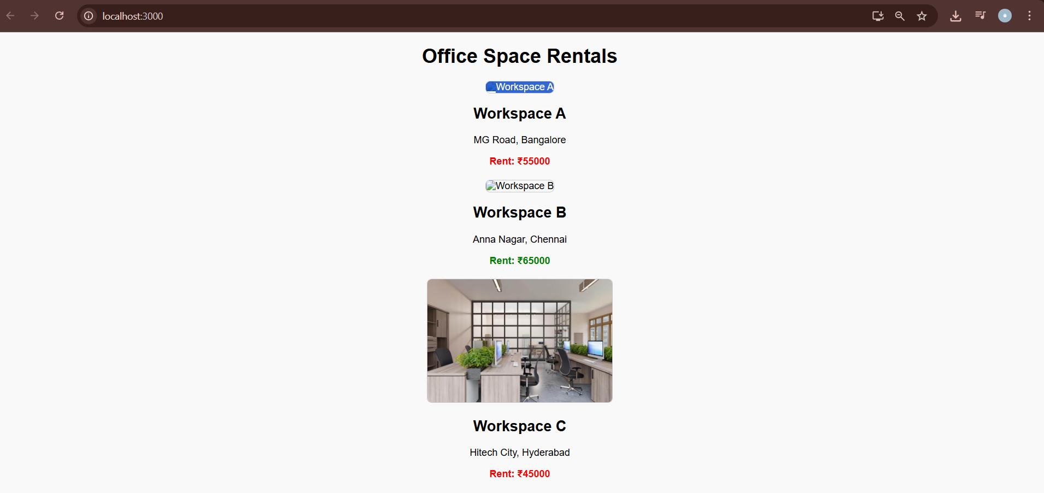

**Create a React Application “eventexamplesapp” to handle various events of the form elements in HTML.**

**Installation**

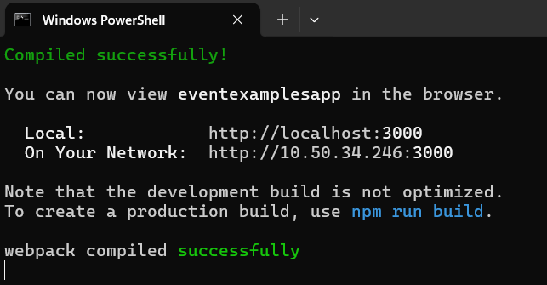

**App.js**

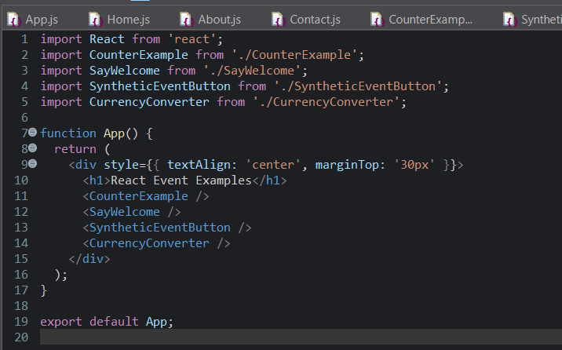

**CounterExample.js**

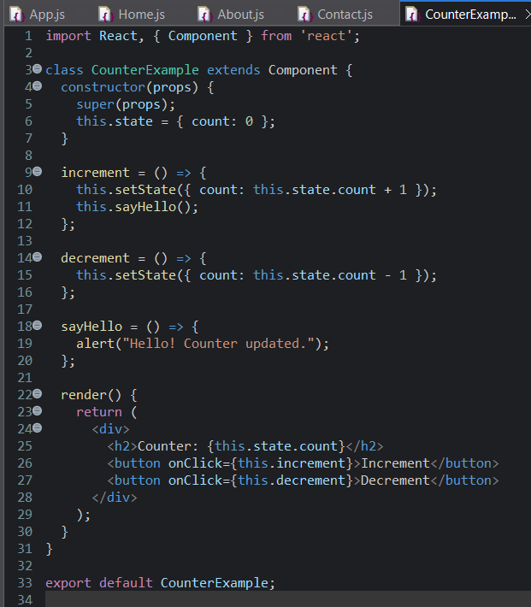

**CurrencyConverter.js**

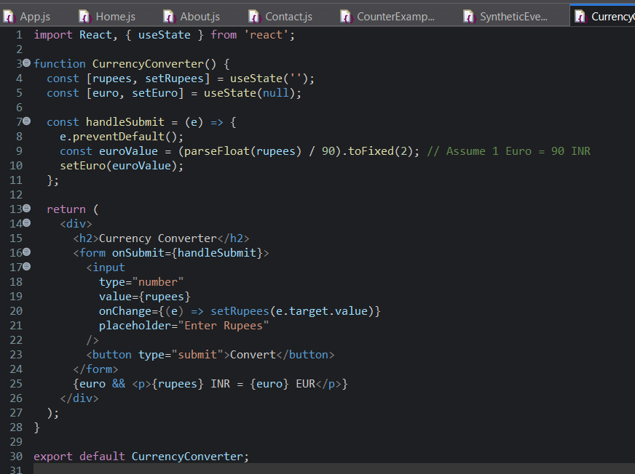

**SayWelcomeButtton.js**

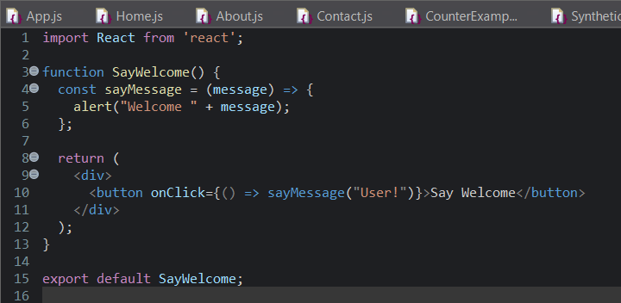

**SyntheticEventButton.js**

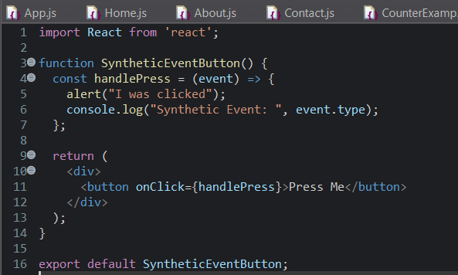

**WelcomeButton.js**

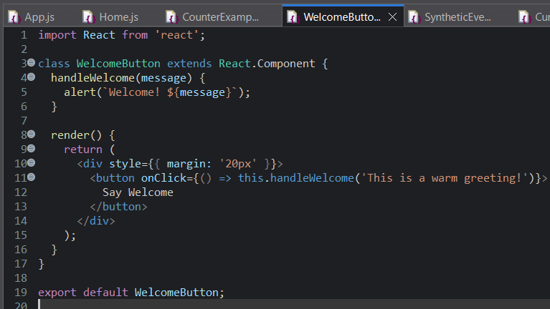

**Output**

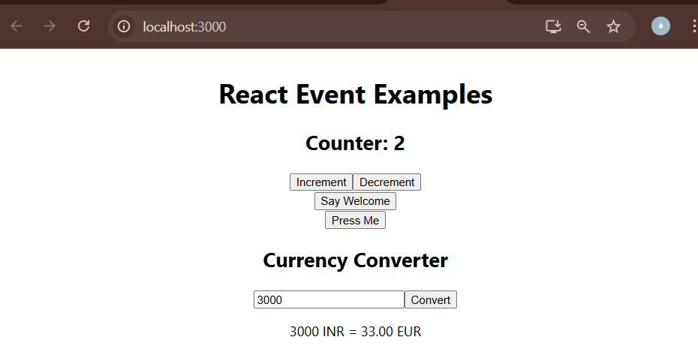

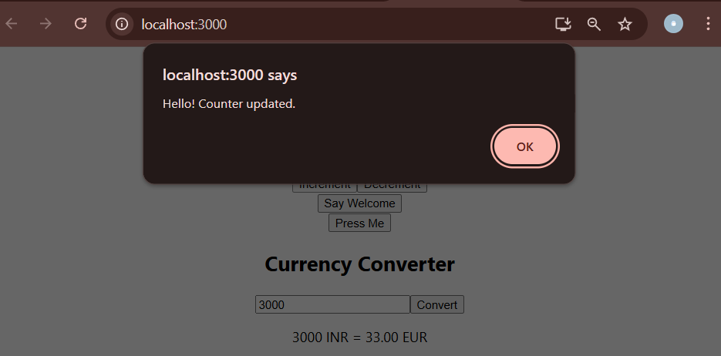

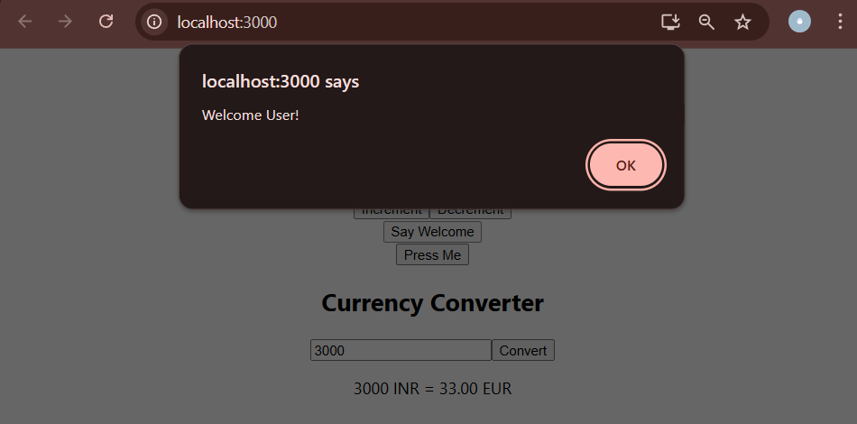

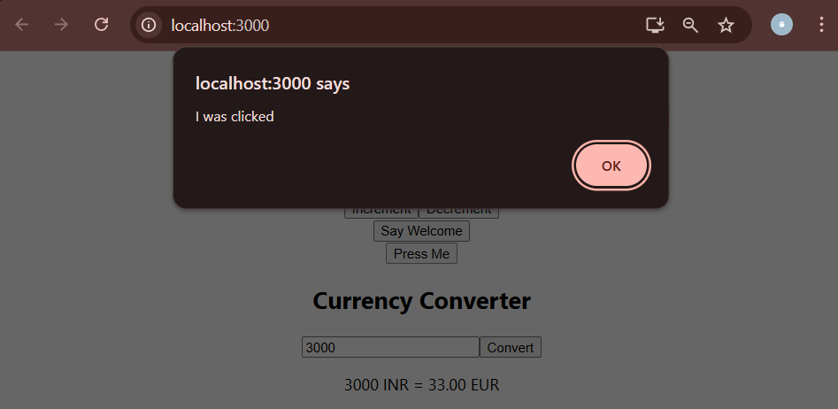

**Create a React Application named “ticketbookingapp” where the guest user can browse the page where the flight details are displayed whereas the logged in user only can book tickets.**

**Installation**

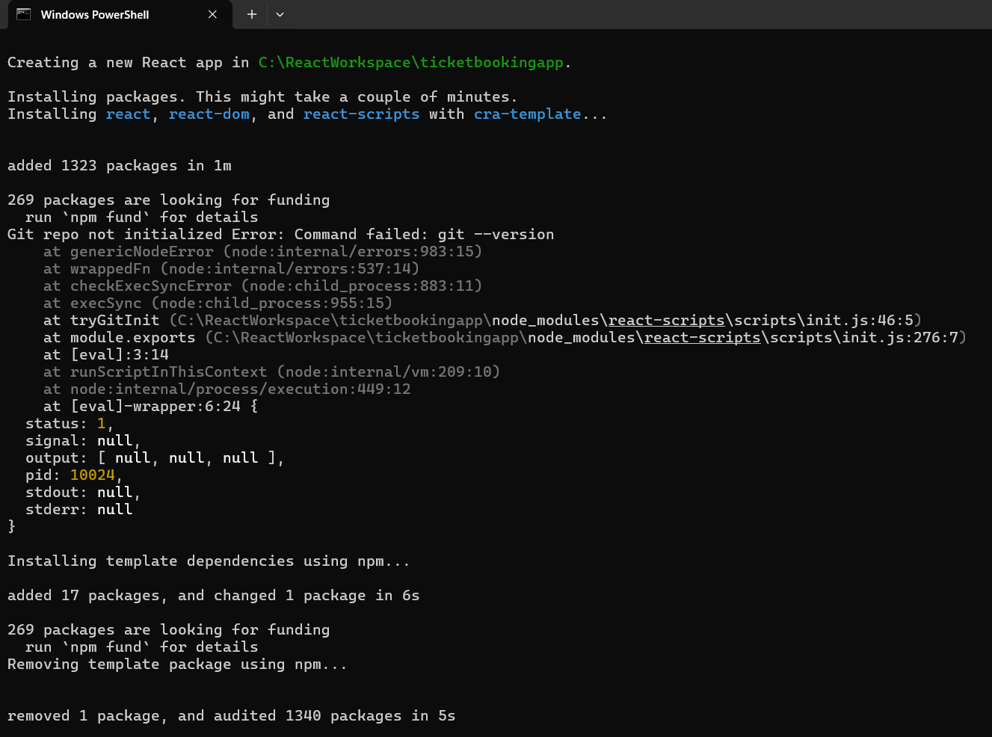

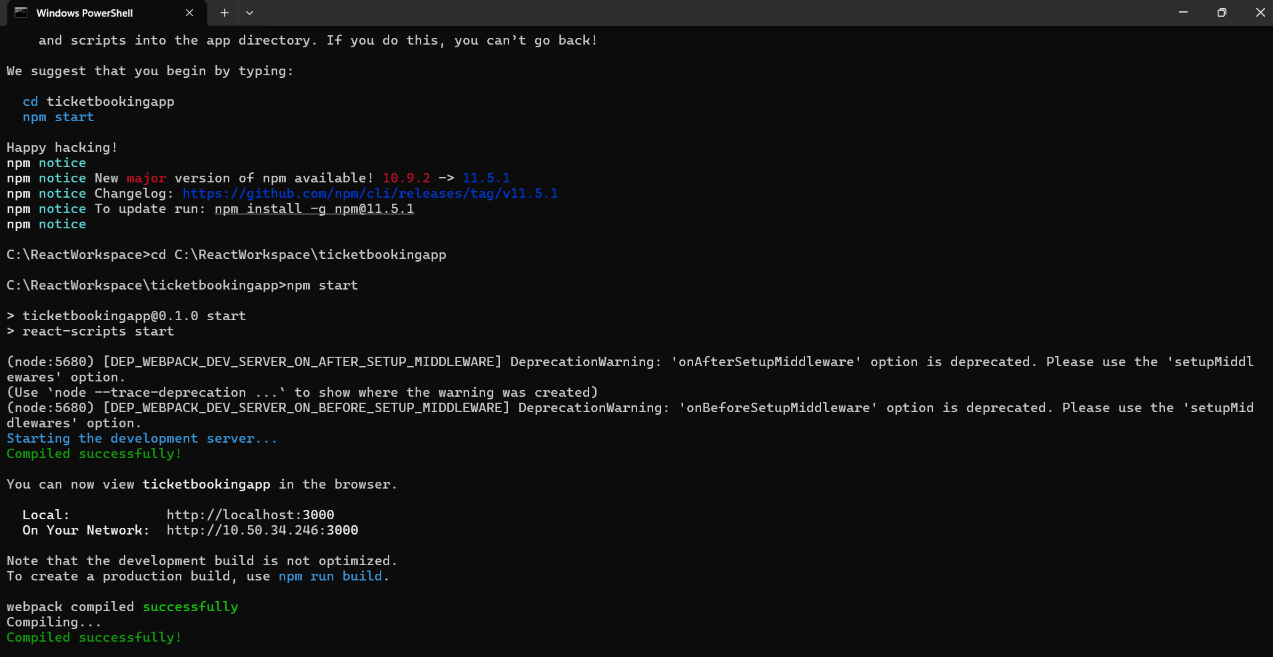

**App.js**

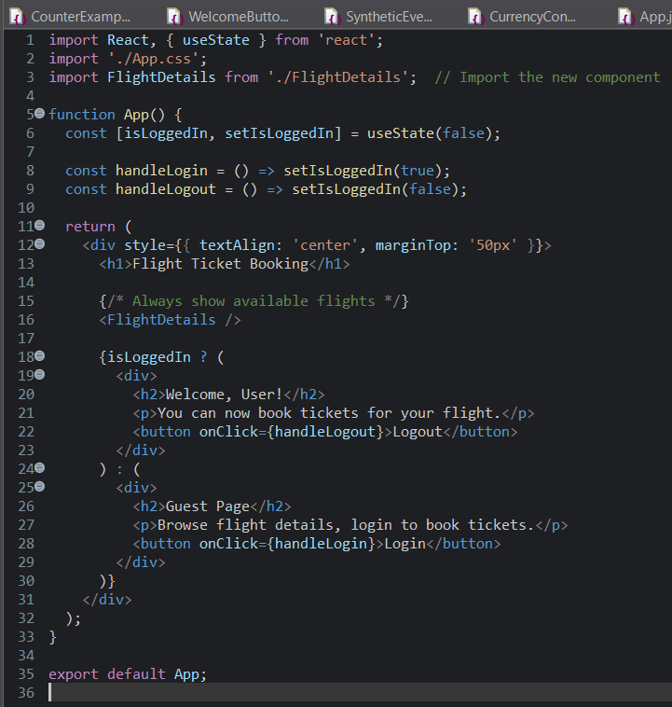

**FlightDetails.js**

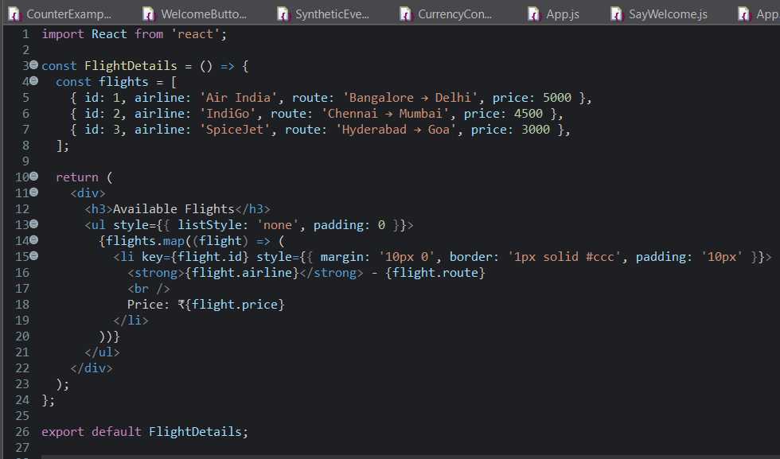

**Output**

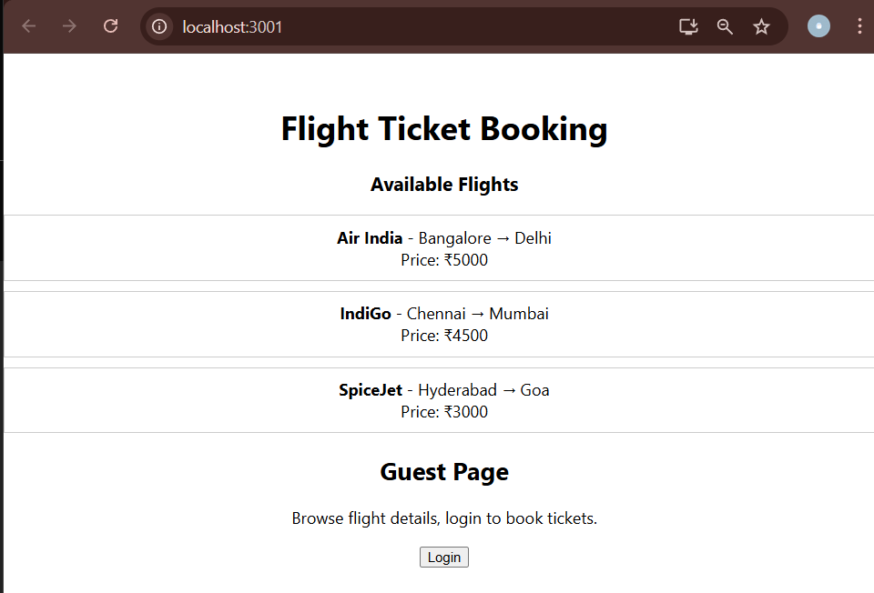

**After Login**

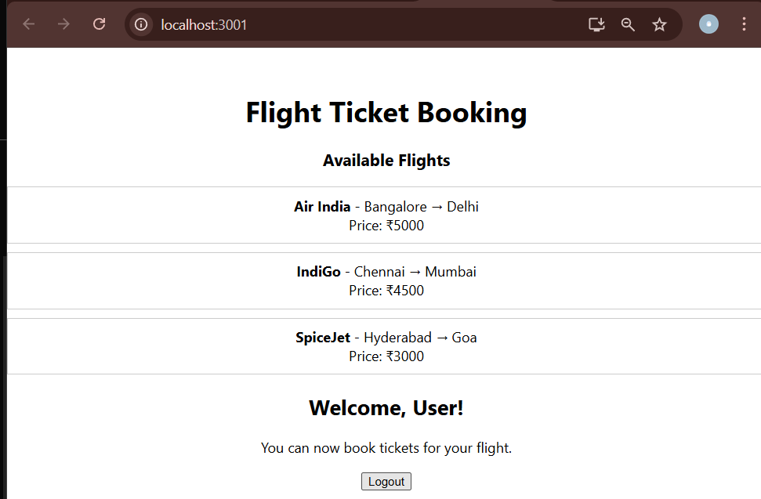

**Create a React App named “bloggerapp” in with 3 components.**

**Installation**

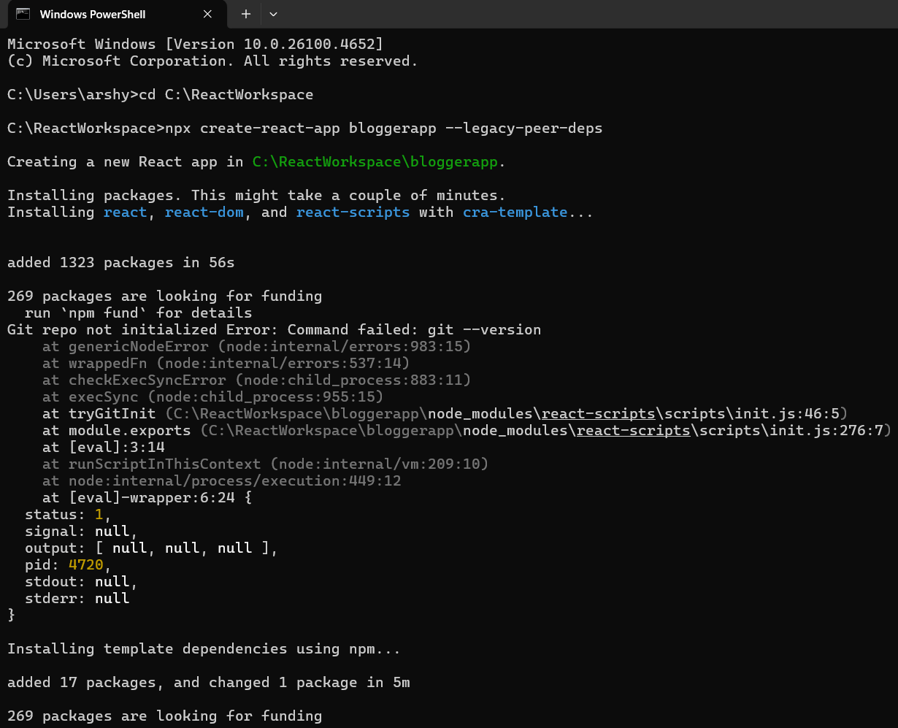

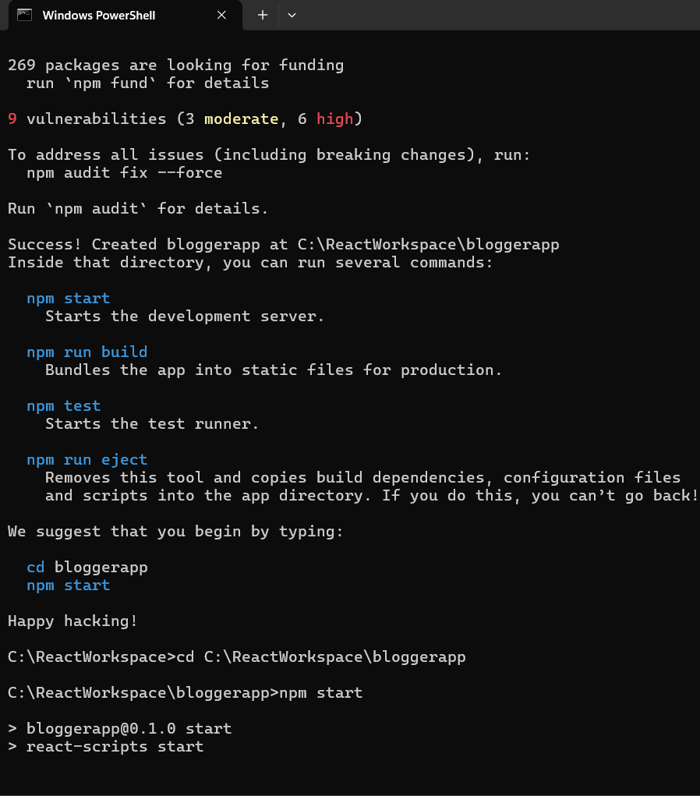

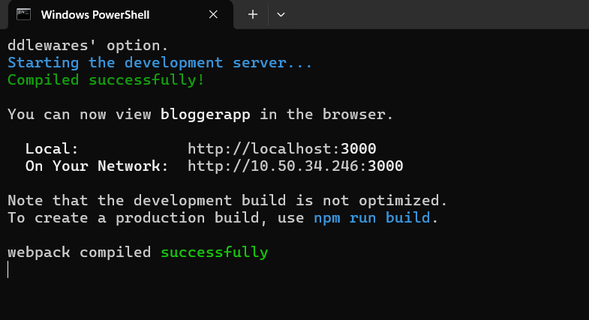

**App.js**

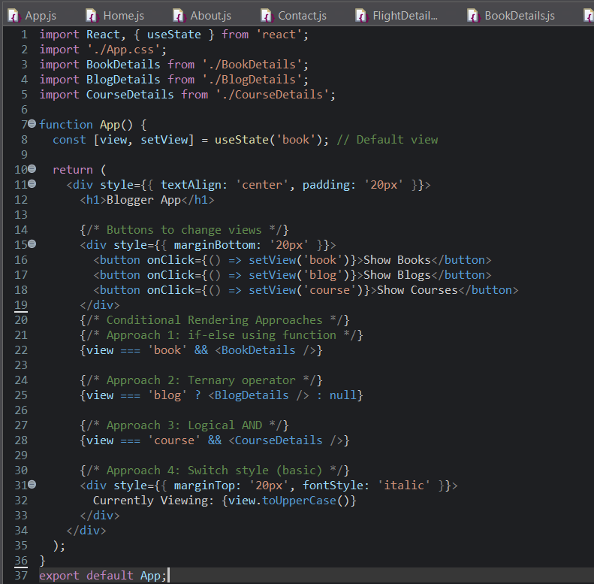

**BlogDetails.js**

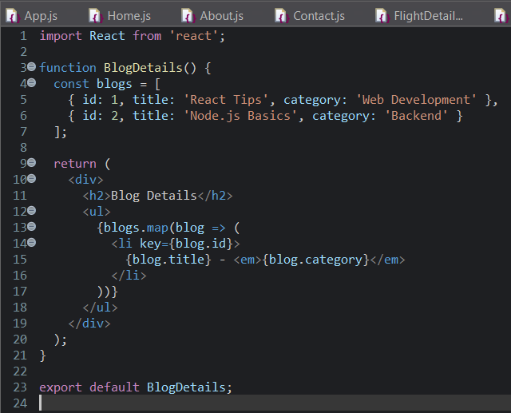

**BookDetails.js**

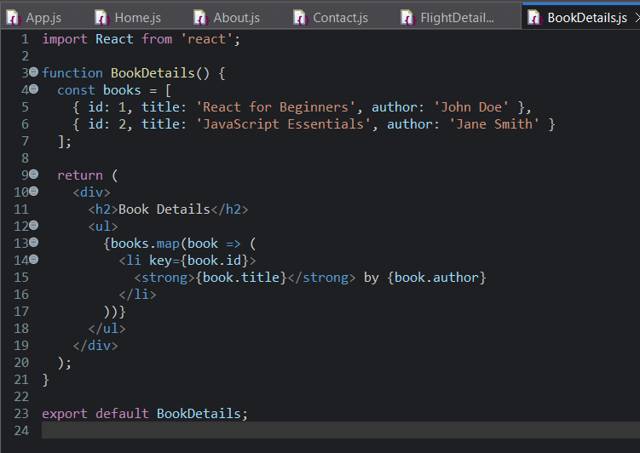

**CourseDtails.js**

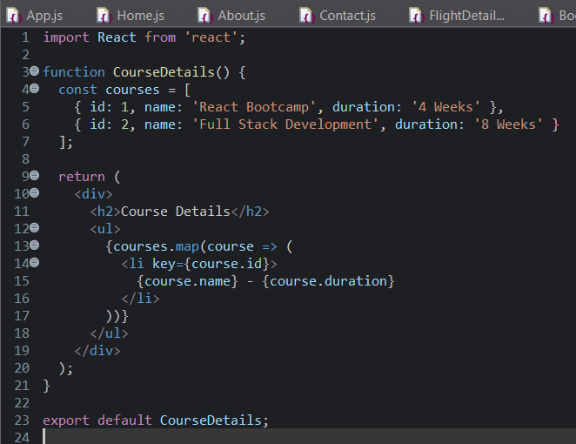

**Output :**

**1.Show Books**

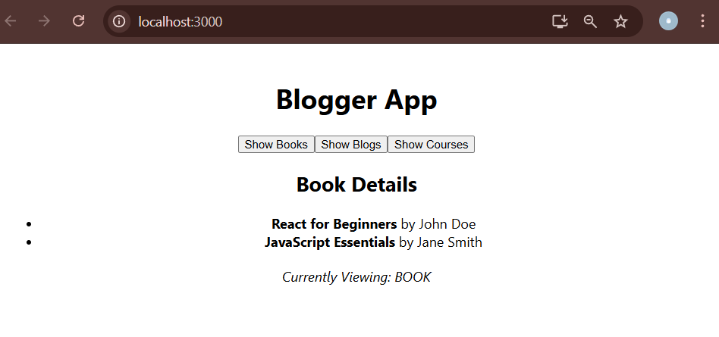

**2. Show Blogs**

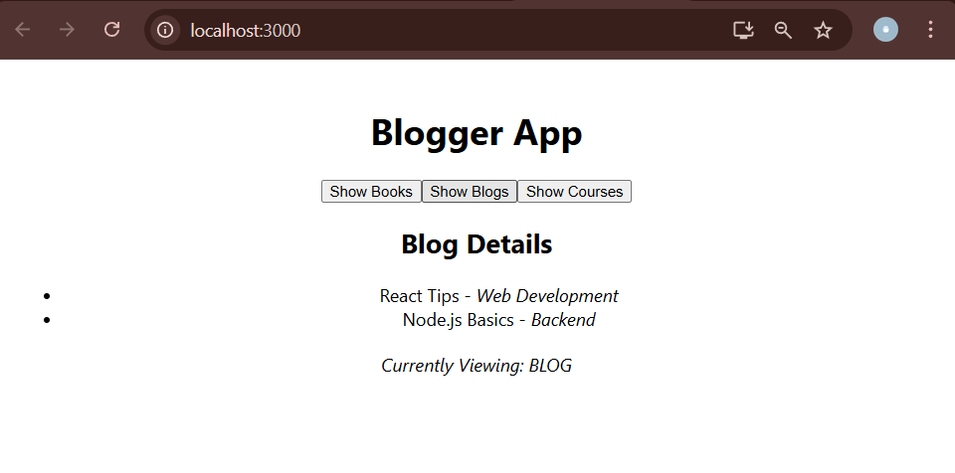

**3. Show Courses**

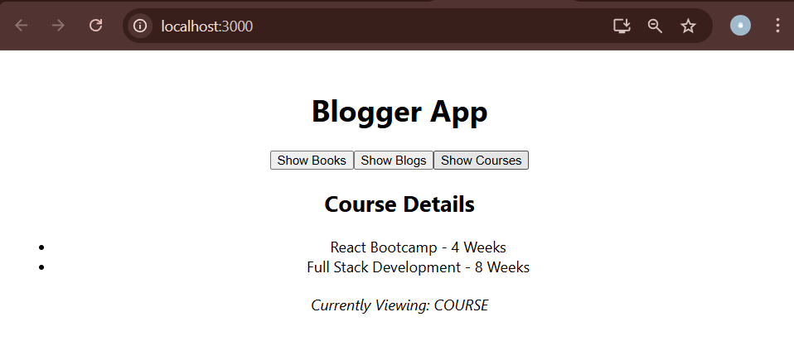

**You are assigned the task of converting the application form props only to React Context API.**

**Installation :**

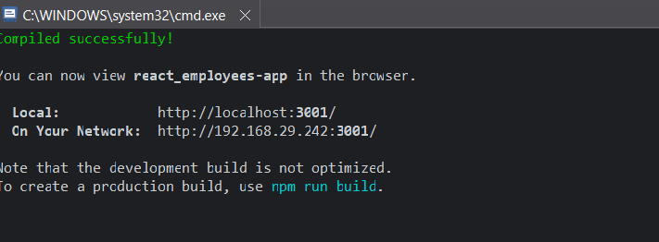

**App.js**

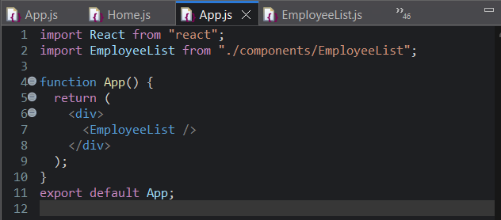

**EmployeeList.js**

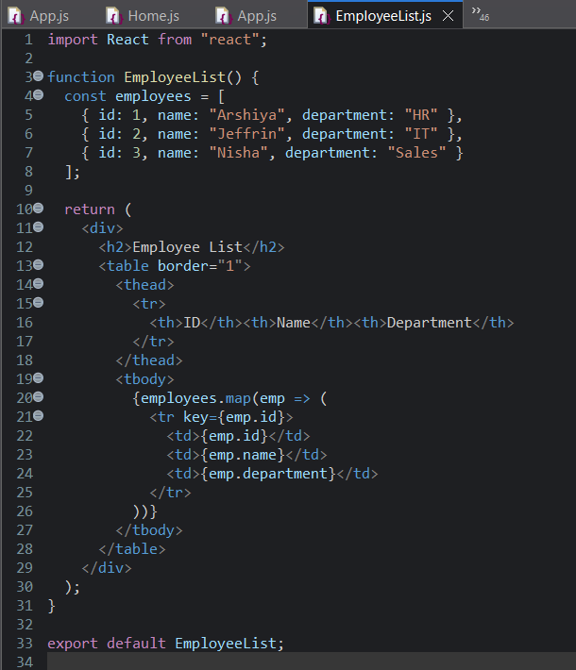

**EmployeeCard.js**

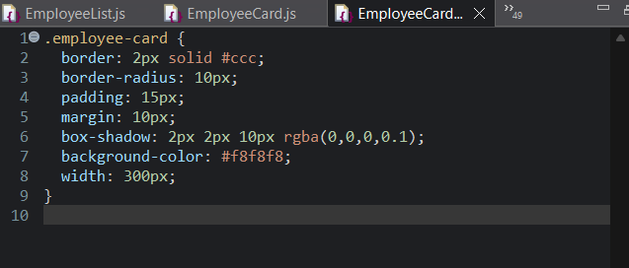

**Output :**

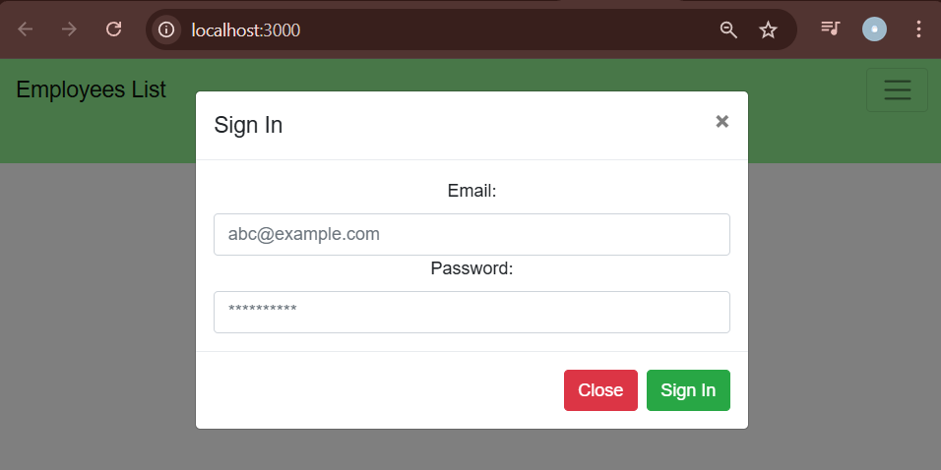

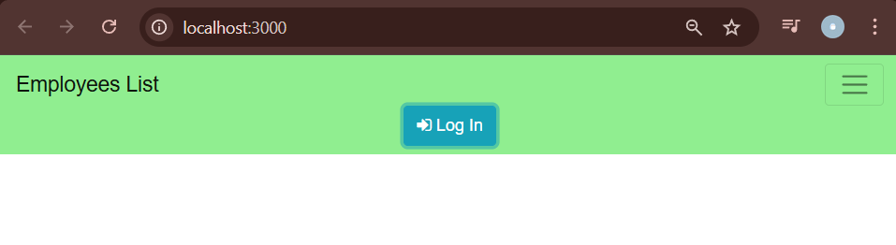

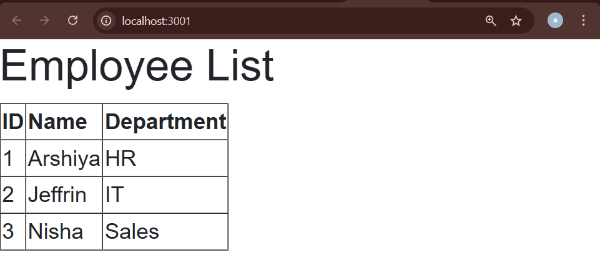

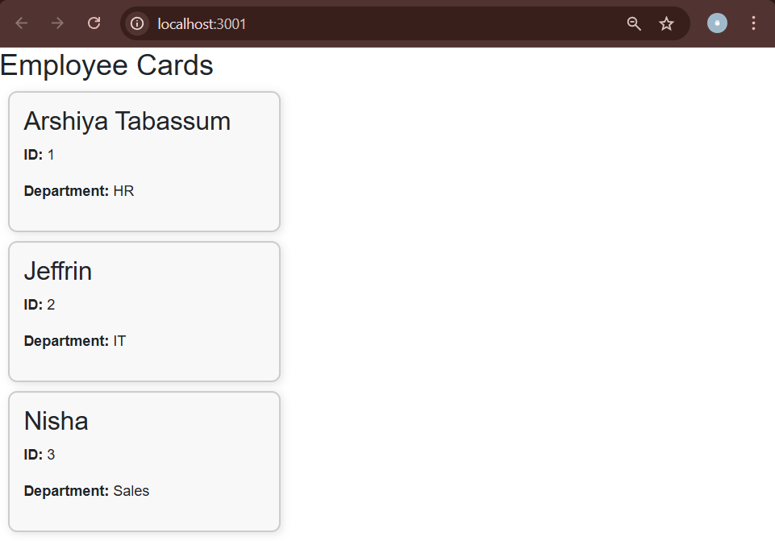

**ComplaintRegister.css**

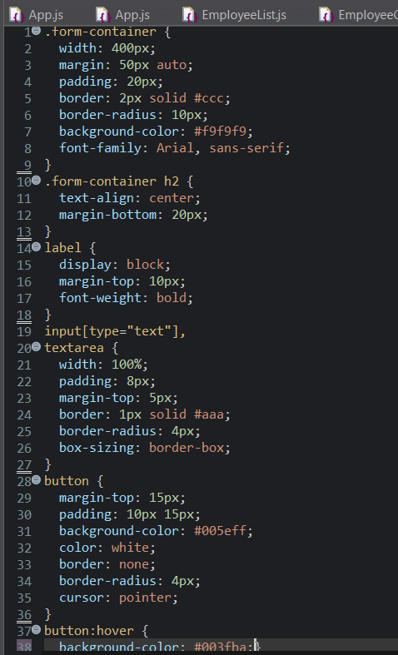

**ComplaintRegister.js**

import React, { useState } from 'react';

import './ComplaintRegister.css'; // Import the CSS

function ComplaintRegister() {

const [employeeName, setEmployeeName] = useState('');

const [complaint, setComplaint] = useState('');

const handleSubmit = (e) => {

e.preventDefault();

if (!employeeName.trim() || !complaint.trim()) {

alert("Please fill out all fields.");

return;

}

const referenceNumber = 'REF' + Math.floor(1000 + Math.random() * 9000);

alert(

`Complaint submitted successfully!\nReference Number: ${referenceNumber}`

);

setEmployeeName('');

setComplaint('');

};

return (

<div className="form-container">

<h2>Raise a Ticket</h2>

<form onSubmit={handleSubmit}>

<label>Employee Name:</label>

<input

type="text"

value={employeeName}

onChange={(e) => setEmployeeName(e.target.value)}

placeholder="Enter your name"

/>

<label>Complaint:</label>

<textarea

value={complaint}

onChange={(e) => setComplaint(e.target.value)}

placeholder="Describe your issue"

rows="4"

></textarea>

<button type="submit">Submit</button>

</form>

</div>

);

}

export default ComplaintRegister;

**App.js**

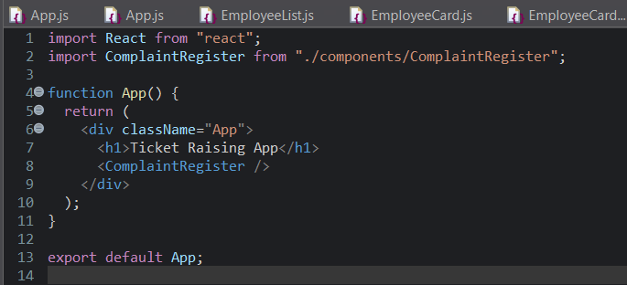

**Output**

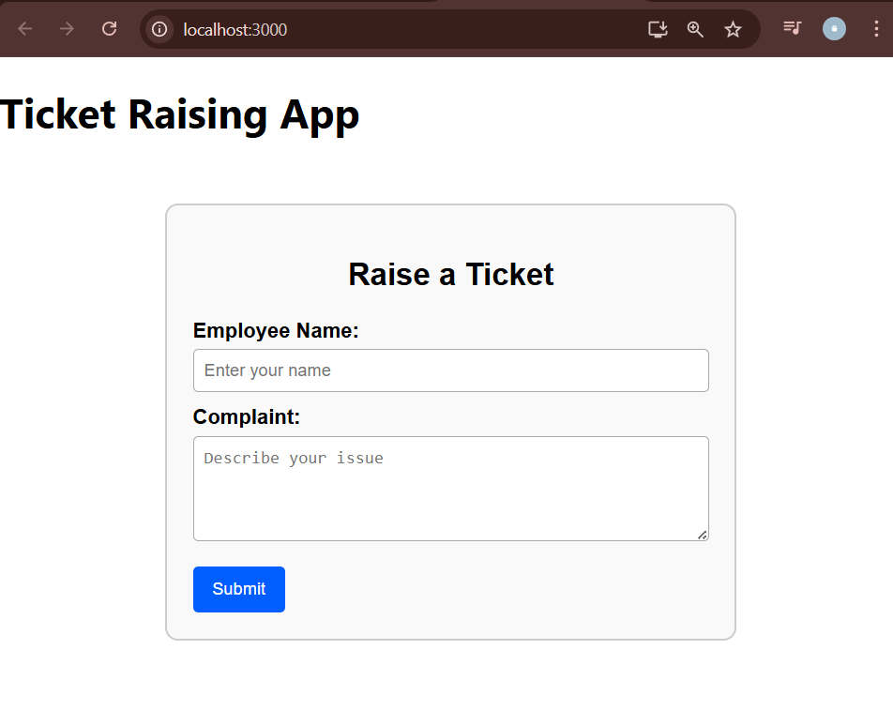

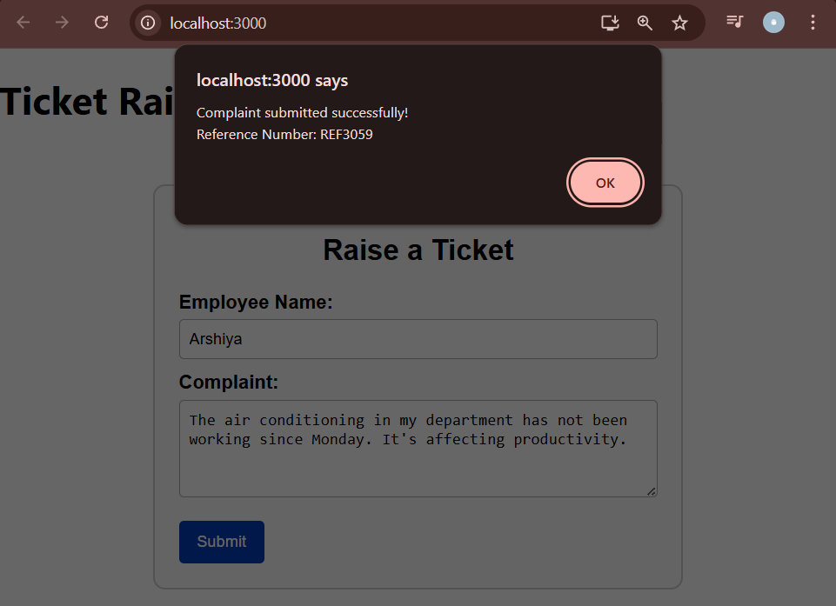

**Create a React App named “mailregisterapp” which will have a component named “register.js”.**

**Installation**

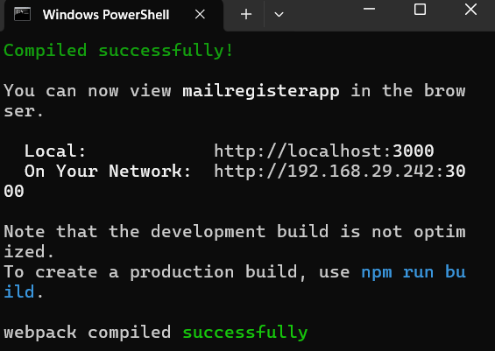

**Register.css**

.form-container {

width: 300px;

margin: 50px auto;

padding: 20px;

border: 2px solid #ccc;

border-radius: 10px;

background-color: #f5f5f5;

box-shadow: 0 4px 8px rgba(0, 0, 0, 0.1);

}

.form-container h2 {

text-align: center;

margin-bottom: 20px;

color: red;

font-size: 24px;

}

.form-container label {

font-weight: bold;

display: block;

margin-top: 10px;

}

.form-container input {

width: 100%;

padding: 8px;

margin-top: 5px;

border: 1px solid #999;

border-radius: 5px;

font-size: 14px;

}

.form-container button {

width: 100%;

padding: 10px;

margin-top: 15px;

background-color: #007bff;

color: white;

border: none;

border-radius: 5px;

font-weight: bold;

cursor: pointer;

transition: background-color 0.3s ease;

}

.form-container button:hover {

background-color: #0056b3;

}

.error {

color: red;

font-size: 13px;

margin-top: 4px;

}

**Register.js**

import React, { useState } from 'react';

import './Register.css';

function Register() {

const [form, setForm] = useState({

name: '',

email: '',

password: '',

});

const [errors, setErrors] = useState({});

const handleChange = (e) => {

setForm({ ...form, [e.target.name]: e.target.value });

};

const validate = () => {

let errors = {};

if (form.name.trim().length < 5) {

errors.name = "Name must be at least 5 characters";

}

if (!form.email.includes('@') || !form.email.includes('.')) {

errors.email = "Invalid email format";

}

if (form.password.length < 8) {

errors.password = "Password must be at least 8 characters";

}

return errors;

};

const handleSubmit = (e) => {

e.preventDefault();

const validationErrors = validate();

if (Object.keys(validationErrors).length === 0) {

alert("Form submitted successfully!");

setForm({ name: '', email: '', password: '' });

setErrors({});

} else {

setErrors(validationErrors);

}

};

return (

<div className="form-container">

<h1 style={{ color: 'red', textAlign: 'center' }}>Register Here!!!</h1>

<form onSubmit={handleSubmit}>

<div>

<label>Name:</label>

<input

type="text"

name="name"

value={form.name}

onChange={handleChange}

/>

{errors.name && <div className="error">{errors.name}</div>}

</div>

<div>

<label>Email:</label>

<input

type="text"

name="email"

value={form.email}

onChange={handleChange}

/>

{errors.email && <div className="error">{errors.email}</div>}

</div>

<div>

<label>Password:</label>

<input

type="password"

name="password"

value={form.password}

onChange={handleChange}

/>

{errors.password && <div className="error">{errors.password}</div>}

</div>

<button type="submit">Submit</button>

</form>

</div>

);

}

export default Register;

App.js

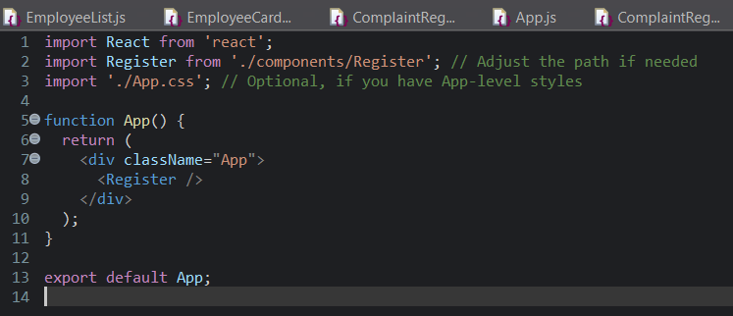

**Output**

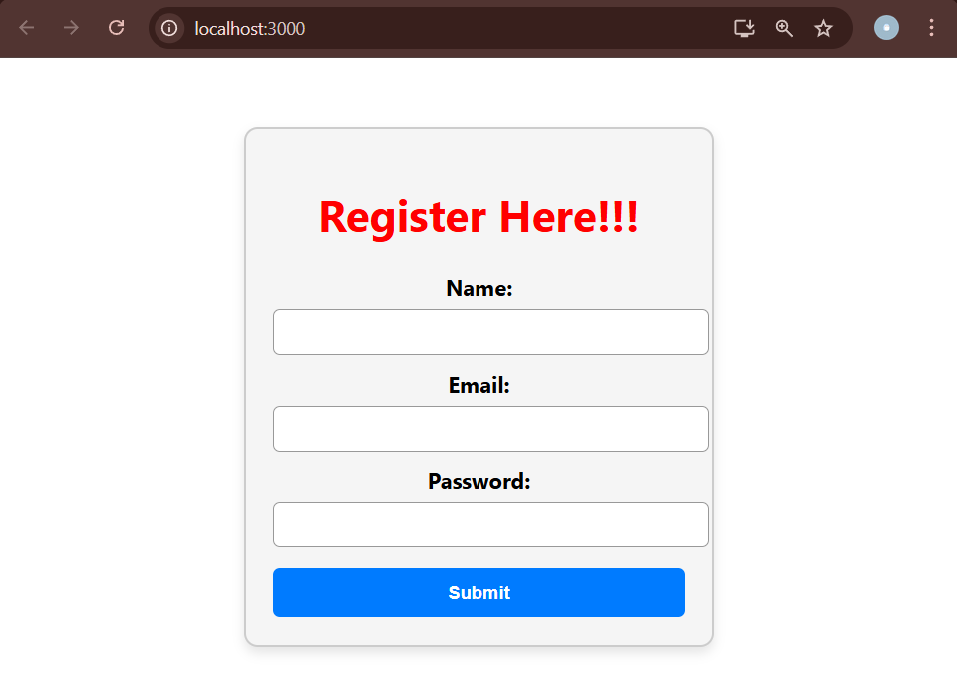

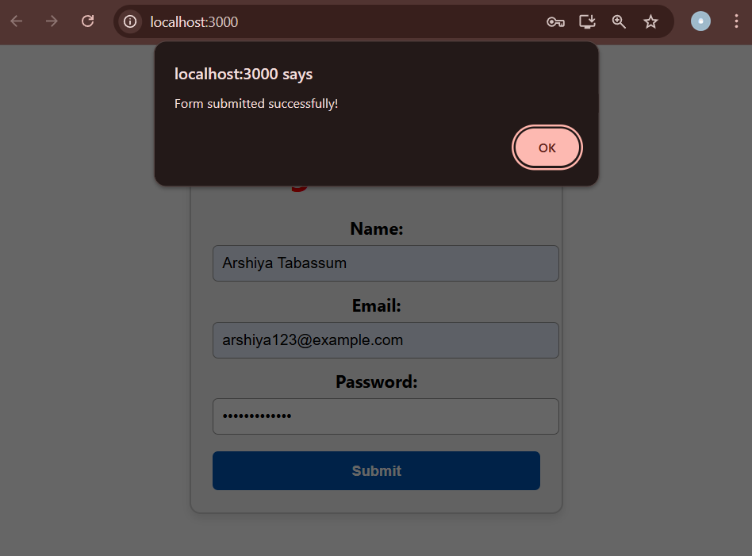

**Create a React Application “fetchuserapp” which will retrieve the user details from** [**https://api.randomuser.me/**](https://api.randomuser.me/) **and display the title, firstname and image of a user.**

**Installation**

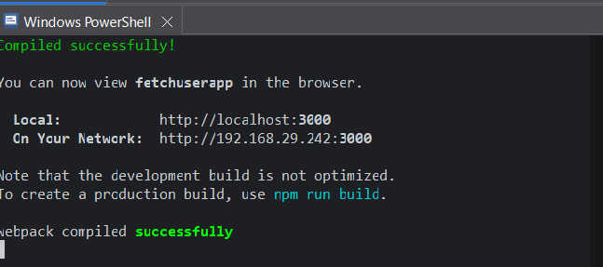

**GetUser.js**

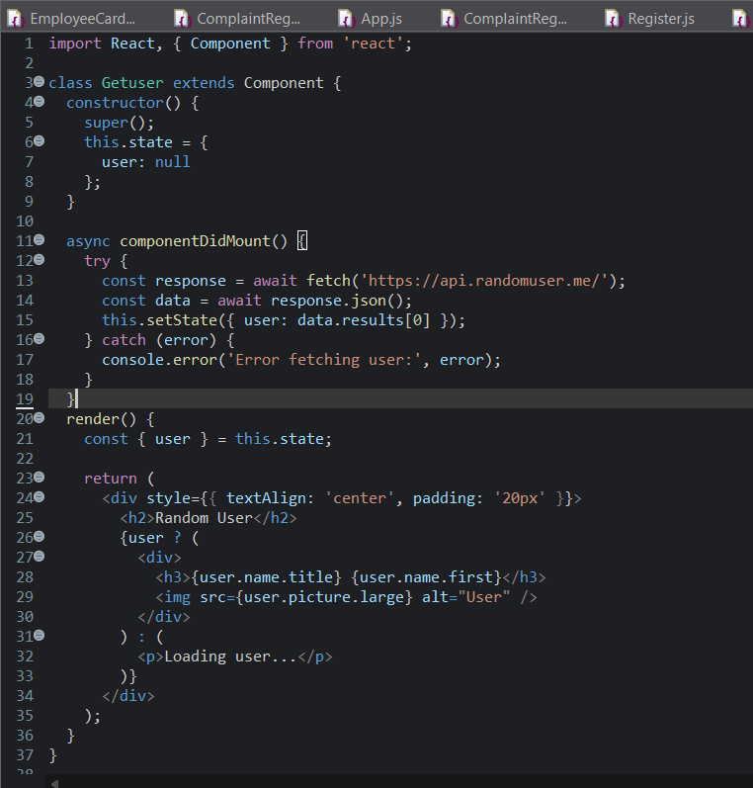

**App.js**

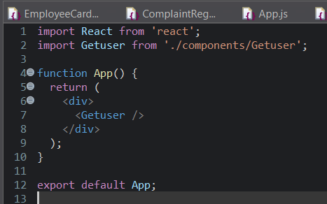

**Output**

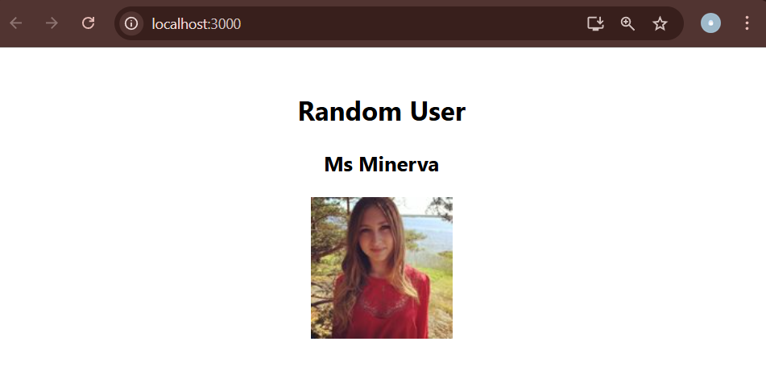

**My Academy team at Cognizant want to create a dashboard containing the details of ongoing and completed cohorts. A react application is created which displays the detail of the cohorts using React component. You are assigned the task of unit testing the component to ensure it’s free of bugs.**

**Installation**

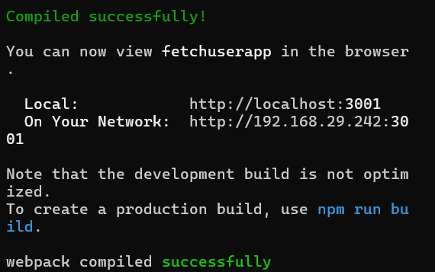

**App.js**

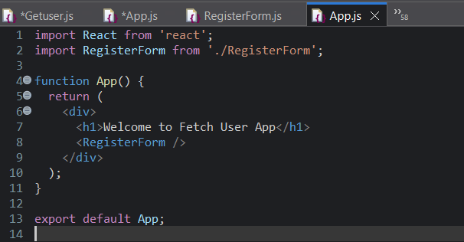

**Output**

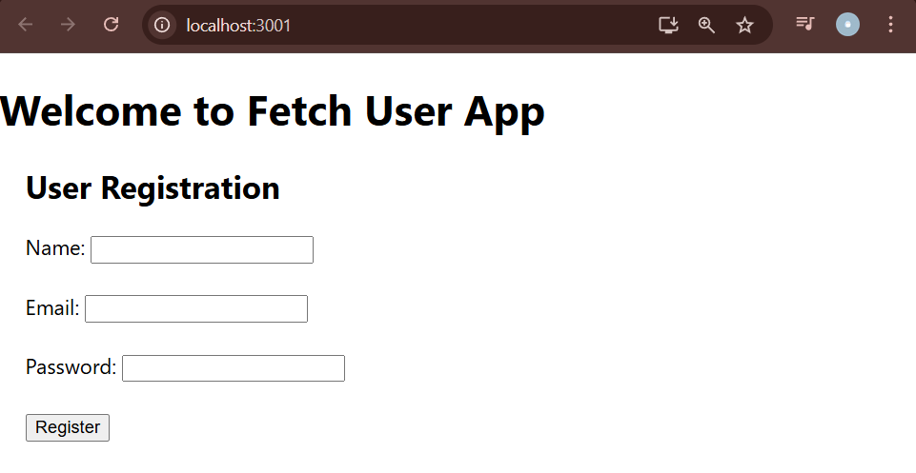

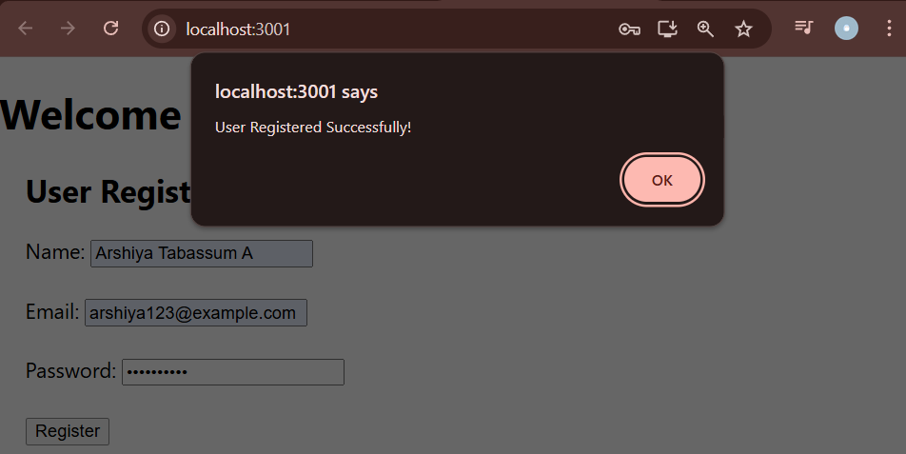

**As an intern at OpenAI you are assigned the task of creating and testing a React application which will fetch and display a list of repository names for a given user.**

**Installation**

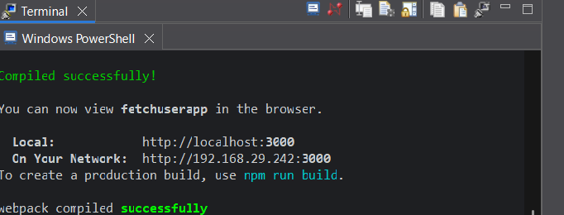

**GitHubUserFetcher.js**

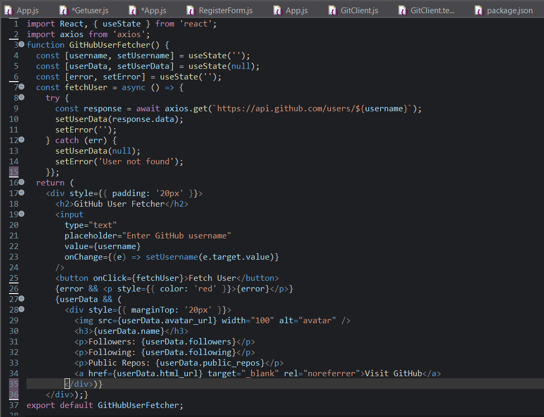

**App.js**

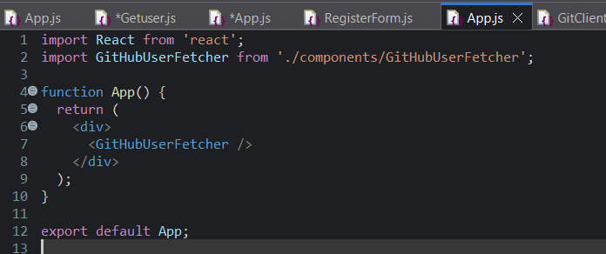

**GetClient.js**

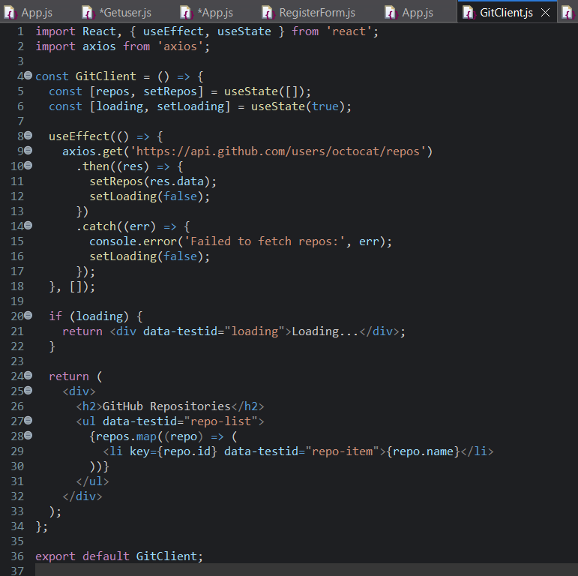

**GetClient.test.js**

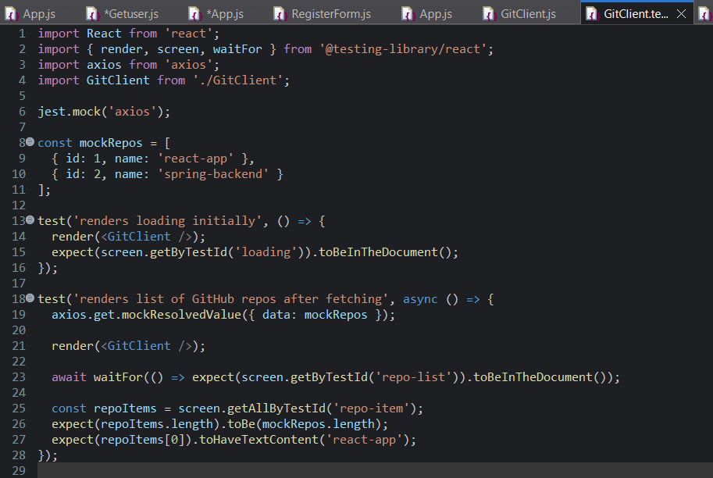

**Output**

